FA17 Bece 0024
MUHAMMAD AFZAL LAB 6

TASK 1
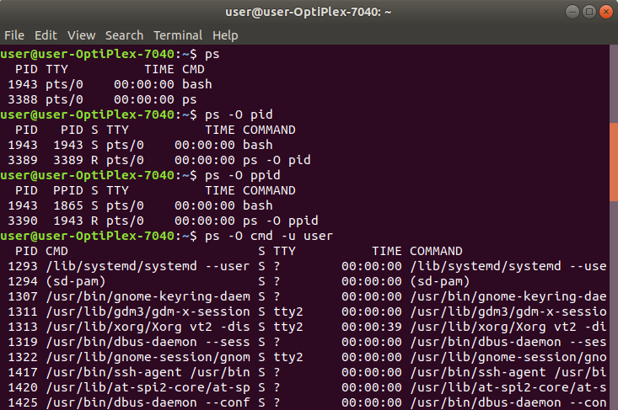

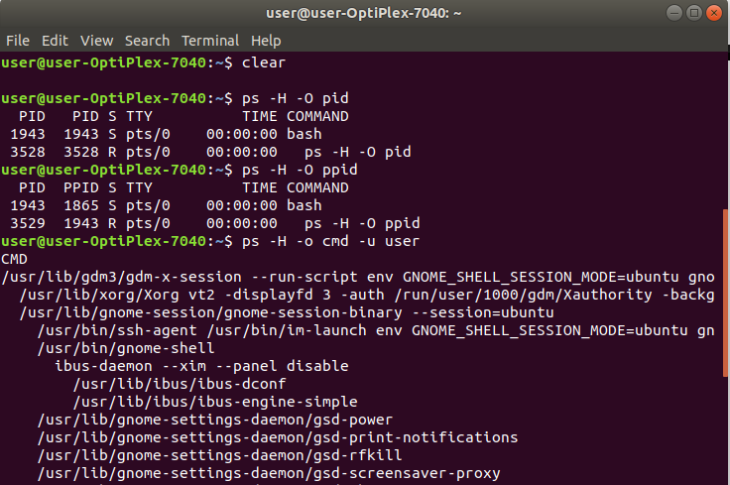
TASK 2

TASK 3

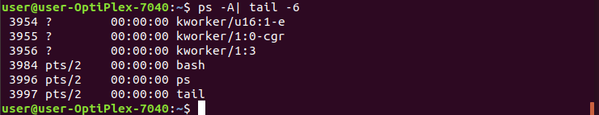
TASK 4
